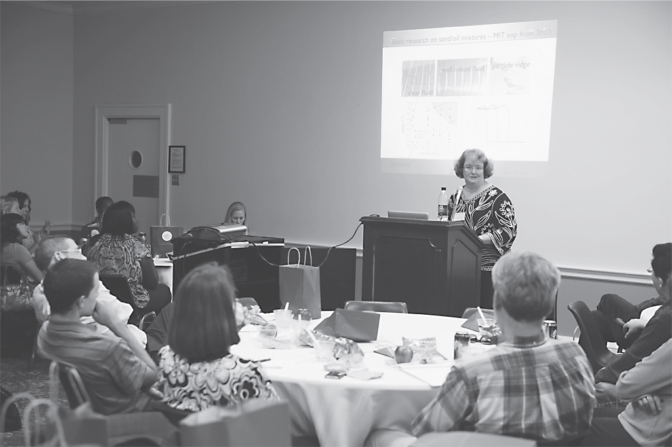

AMS Hosts Congressional Briefing

On October 12, 2010, the AMS hosted a briefing on Capitol Hill titled “The Gulf Oil Spill: How Can We Protect Our Beaches in the Future?” Andrea Bertozzi, professor of mathematics at UCLA, delivered the address to Congressional representatives. She discussed how scientific modeling
and basic research in mathematics is helping in the understanding of the impact of this major environmental problem. Her research examines the dynamics of oil-sand-water mixtures in an effort to provide more efficient cleanup and protection methods for oil spills such as the
one that occurred in the Gulf of Mexico this year.

—AMS announcement (excerpt from page 73 Notices of the American Mathematical Society, January 2011)

